PARTICIPANT RISK ASSESSMENT AND DISASTER MANAGEMENT PLAN

PARTICIPANT DETAILS NDIS Number:
Given name/s: |  |  |  |  |  | Family name
Preferred name: |  |  |  |  |  | Date of birth
Address: |  |  |  |  |  | Phone No:
Preferred contact  Method: |  | Phone |  |  |  | Email:
KNOWN MEDICAL CONDITIONS OR ALLERGIES
Specify |  | Effect |  |  |  | Treatment
None Known
EMERGENCY CONTACTS/CARER/GUARDIAN
Name/s: |  |  |  |  |  | Phone:
Email:
PERSONS INVOLVED IN RISK ASSESSMENT
Was the participant involved in the assessment? |  |  | YES  NO | Reason:
 |  |  | YES  NO | Reason:
Staff Involved
Others Involved
INDIVIDUAL RISK ASSESSMENTS
No. | Item |  |  |  | Y/N |  | Risk Rating | Comments/Controls
1 | Is the client able to open door? |  |  |  | YESNO |  | L
2 | Is there a safe evacuation point at your home? |  |  |  | YESNO |  |  | Location:
3 | Is the service to be provided at night or outside of normal working hours? |  |  |  | YESNO
4 | Are there the any expressive language concerns? |  |  |  | YESNO
5 | Has relevant medical history been communicated including potential risk situations? |  |  |  | YESNO
6 | Does the Participant have any road safety skills? |  |  |  | YESNO
7 | Can the participant travel in an unmodified vehicle? |  |  |  | YESNO
8 | Can the participant use public transport? |  |  |  | YESNO
9 | Is the client known to be affected by crowds? |  |  |  | YESNO
10 | Is the client affected by noises or sudden sounds? |  |  |  | YESNO
11 | Is there a history of any family members with behavioural issues |  |  |  | YESNO |  |  | Is there a behaviour practitioner involved?  YESNO
12 | Does the client have mobility issues? e.g., wheelchair or other? |  |  |  | YESNO
13 | Have hazards associated with showering, sponging and toileting been considered?  e.g., manual handling/ slips trips and falls biological hazards/ humidity, etc.) |  |  |  | YESNO
14 | Does the participant take any of the following medications that can cause Respiratory Depression?  ☐ Benzodiazepines  ☐ Opioids  ☐ Polypharmacy  ☐ Psychotropic polypharmacy  ☐ combination of any of the above medications |  |  |  | Yes  No  If yes, please specify and capture this in the controls table
MEDICATION
Management of Medication
Should any of the below be marked as YES, refer to Form 24. Management of Medication
Prompt Medication Required
YES NO
Assistance of Medication Required
YES NO
Administration of Medication Required
YES NO
NO – This participant does not require medication management

Participant Dependency and Health-Safety Risk Assessment Table
Steps to Use the Extended Table:
- Assessment: Evaluate both the level of reliance on your services and the potential impact on health and safety for each participant.
- Categorisation: Assign the appropriate risk level based on the combined assessment of reliance and health-safety impact.
- Mitigation: Develop strategies and contingency plans that address not only the level of reliance but also the specific health and safety concerns identified for each risk level.
- Regular Review: Continuously review and update the risk assessment and mitigation strategies, considering any changes in participants' needs and potential risks.
- Communication: Ensure that all stakeholders, including participants, families, and your team, understand the dual assessment of reliance and health-safety impact, as well as the corresponding mitigation plans.
- Emergency Planning: For participants with higher risk levels, develop emergency plans that outline steps to be taken in case of service disruptions or unexpected events.
By considering both the participants' level of reliance on the services and the potential consequences for their health and safety in case of disruptions, we can create a more comprehensive risk assessment framework that prioritises their well-being. Therefore, prioritising the health and safety of participants is a fundamental responsibility that promotes their well-being, respects their rights, and contributes to the overall success and sustainability of various activities and endeavours, and ultimately, the level of support the provider is required to provide the participant during their care.
Risk Level | Description | Criteria | Impact on Health-Safety | Select risk level
Low | Participants have a low reliance on provider services to meet daily living needs. | Participants can independently perform most daily living activities without assistance. Any disruptions in services would have minimal impact on their overall well-being. | Disruptions in services would have minimal impact on participants' health and safety, as they can manage most activities independently.
Moderate | Participants have a moderate reliance on provider services for certain daily living needs. | Participants can perform some daily activities independently but rely on the provider for specific tasks such as transportation, meal preparation, or medication management. A disruption in services could moderately affect their overall well-being. | Disruptions in services could moderately impact participants' health and safety, particularly for tasks they rely on the provider to assist with.
High | Participants have a high reliance on provider services to meet essential daily living needs. | Participants require significant assistance from the provider for activities of daily living, including personal care, mobility, meal preparation, and medication management. A disruption in services would have a significant impact on their overall well-being and quality of life. | Disruptions in services would significantly impact participants' health and safety, as they rely heavily on the provider for essential tasks. There could be risks related to personal care, medical needs, and more.
Critical | Participants have a critical reliance on provider services for all daily living needs. | Participants are entirely dependent on the provider for all activities of daily living, including personal care, mobility, communication, medical support, and more. Any disruption in services would pose a severe and immediate threat to their health and well-being. | Disruptions in services would pose a critical threat to participants' health and safety. Their complete dependency on the provider means that any interruption could lead to life-threatening situations.

Participant household safe meeting point
Address
Description
IF RISK IS IDENTIFIED, PLEASE DISCUSS WITH THE MANAGER
Issue/Task | Risk Score | Control Measure | Person Responsible

RISK ASSESSMENT MATRIX
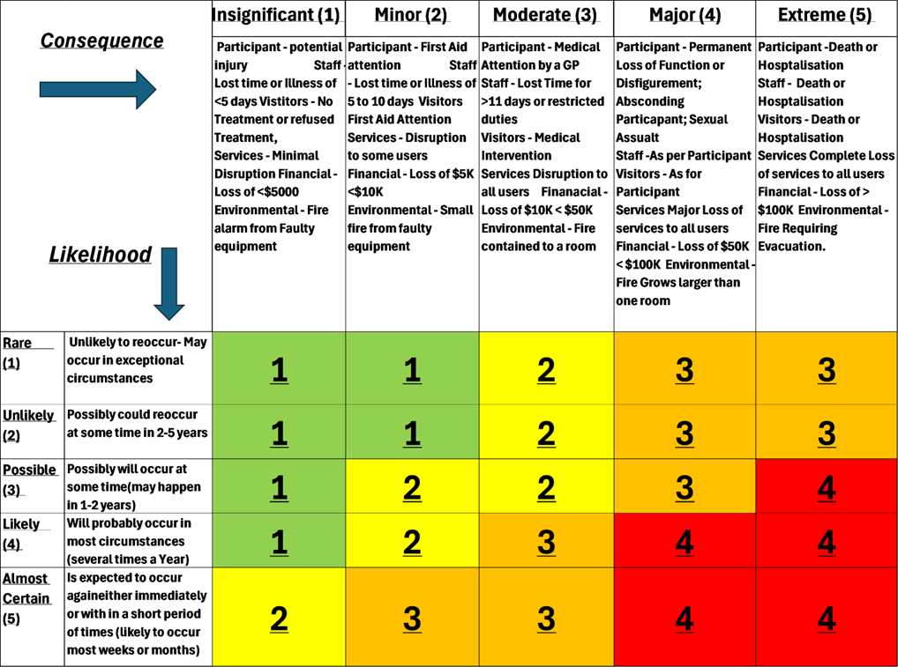
Risk Assessment Outcome – Proceed with Visit as follows:
LOW GREEN
Visit acceptable. Ensure control options are followed.

MEDIUM YELLOW

Visit should only proceed after consultation with Manager. The risks should be reviewed to consider all the hazards involved. The risks must be reduced prior to the visit – if in doubt, re-classify as Moderate Risk.
MODERATE ORANGE
Visit should only proceed after consultation with Director. The risks should be reviewed to consider all the hazards involved. The risks must be reduced prior to the visit – if in doubt, re-classify as High Risk
HIGH RED
Visit must only proceed with Director approval. The risks associated with the visit must be re-assessed & other options considered.
DISASTER MANAGEMENT PLAN
EMERGENCY CONTACT DETAILS
Emergency Contact Numbers
Police |  | 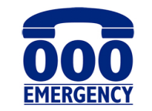
Fire
Ambulance
Utilities
Electricity Authority | Western Power | 13 13 51
Water Authority | Water Corp | 13 13 75
Gas Authority | Gas Corp | 13 13 52
State Emergency | SES | 13 25 00
Other Key Contacts
Health Direct | 1800 022 222
Poisons Line | 13 11 26
Lifeline (24 hours crisis counselling) | 13 11 14
Beyond Blue | 1300 22 4636
Crisis Care | 1800 199 008
NDIS | 1800 800 110
Mental health Emergency Response Line | 1300 555 788 (Perth)  1300 676 822 (Peel)
Type of support to be put in place in the event of an emergency or disaster and how we will support the participant (based on the Service agreement)
Emergency |  | Support provided to the participants in the event of an emergency
Infinity is unable to support for extended period |  | Infinity will assist the client/family to source alternative providers
Client taken ill during support. |  | Call 000, Call family, take to nearest ED
Closure of business |  | Infinity will assist the client/family to source alternative providers
Pandemic |  | Client will reside with family, have essential supports and daily phone check ins
Mode of Communication assessment for non-verbal participants (e.g., Sign language, pictures, body movement)
Possible scenarios of concern |  | Mode of communication

What to do in an Emergency?
Evacuation Procedures | FIRE
Upon hearing the alarm or when the situation requires the participant to leave the premises:  - Prepare to evacuate.  - Get your environment ready to be left unattended. Shut down electrical/electronic devices; turn off gas if safe to do so.  - For fire, close the doors as you go – do not lock them. In the case of a bomb threat, leave doors open.  - Assist participant in immediate danger.  - Leave the building via the nearest safe route.  - Obey all directions from emergency services.  - Move calmly to assembly point  - Follow closely the instructions of emergency services personnel and campus wardens.  - Wait for the OK to re-enter the building. | - Ring 000 and provide details of the fire then ring supervisor.  - Assist any person in immediate danger only if safe to do so.  - If safe to do so, close doors to minimise spread of fire.  - Attack the fire only if safe to do so.  - Contact the nearest warden and follow their instructions (if applicable)  - Assist with evacuation of participants with mobility issues.  - Move to the evacuation location in plan and stay there until all clear has been given.  - Follow closely the instructions of emergency services personnel and campus warden.
Medical Emergency | Civil Disturbance
Assess the situation:  - Do not move a participant unless they are exposed to a life-threatening situation.  - In emergency situations contact the ambulance service by dialling 000 then ring supervisor.  - Arrange for the ambulance to be met.  - Remain with the participant and administer first aid as appropriate until assistance arrives.  - Follow closely the instructions of emergency services personnel. | - Keep well clear of the disturbance and do not say or do anything that may encourage irrational behaviour.  - Consider locking down the building to prevent unauthorised entry.  - Follow closely the instructions of emergency services personnel and campus wardens.  - Evacuate the building only if instructed to do so by emergency services personnel or campus warden
Extreme Weather | Personal Preparation
- Keep participant informed of situation.  - Move around premises and turn off electrical appliances to ensure safety.  - Follow closely the instructions of emergency services personnel  - Evacuate the building only if instructed to do so by emergency personnel.  - Keep in contact with supervisor and follow their instructions. | - Know the location of emergency exits in your building.  - Plan an escape route from the premises to safe environment.  - Identify and familiarise yourself evacuation point or a safe location.  - Familiarise yourself with location of any break glass fire alarms.  - Note location of fire extinguishers.  - Familiarise yourself with the identity and location of the first aid kits.

Authorisation
Authorised by: |  |  |  | Role:
Signature: |  |  |  | Date:
Participant / Guardian  Signature: |  |  |  | Date:
Is a copy supplied to the participant? | YES  NO | Copy placed on file? | YES  NO | Date for Review:

